**Coding Assessment-MongoDB-Relationships**

**One-to-one Relationship**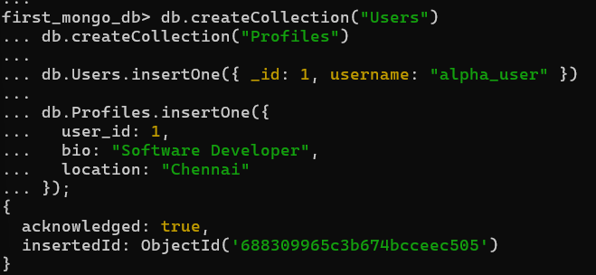

**Creation and Insertion of Collections and**

**Documents.**

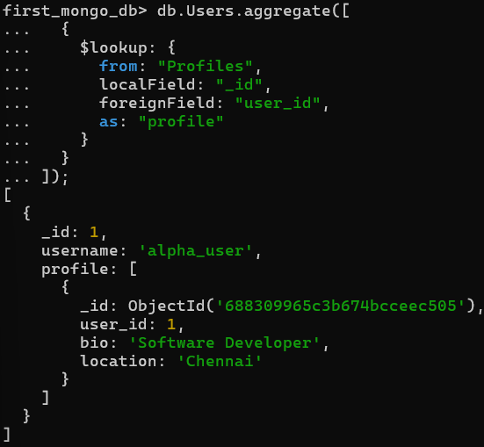

**$lookup query to join the 2 collection to retrieve**

**required data**

**One-to-Many Relationship**

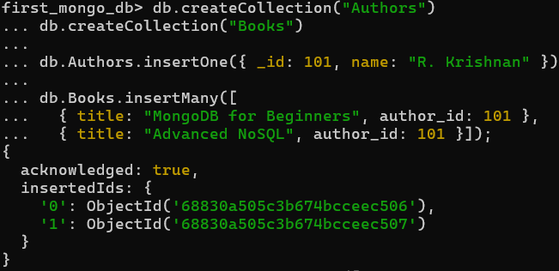

**Creation and Insertion of Collections and**

**Documents**.

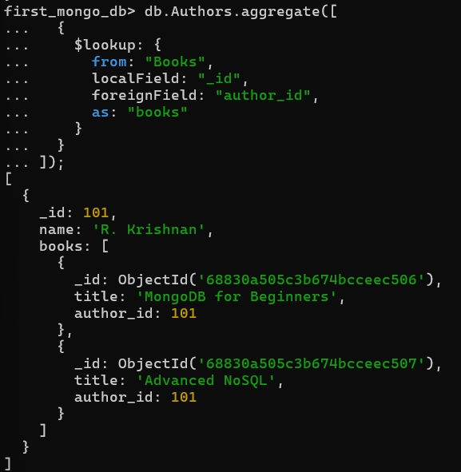

**$lookup query to join the 2 collection to retrieve**

**required data**

**Many-to-One Relationship:**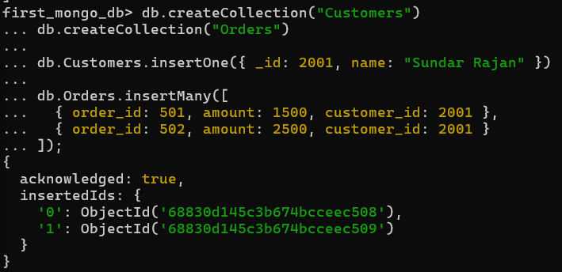

**Creation and Insertion of Collections and**

**Documents.**

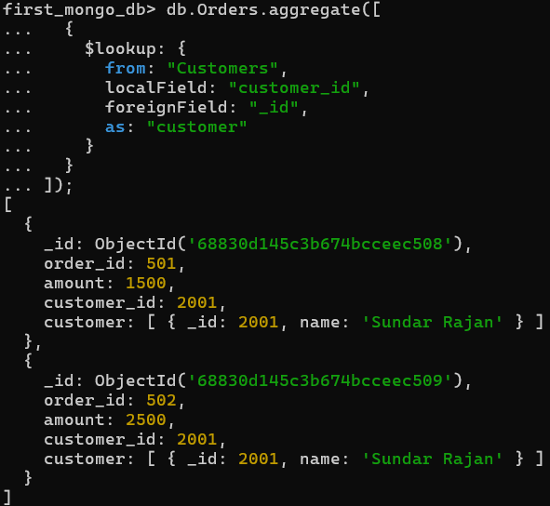

**$lookup query to join the 2 collection to retrieve required data**

**Many-to-Many Relationship:**

**Creation and Insertion of Collections and Documents.**

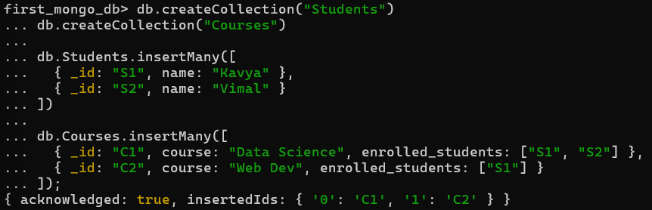

**$lookup query to join the 2 collection to retrieve required data.**

